7 Steps to Being Prepared for an Injury

- Create written procedure to be included in Policy/Procedure manual or Employee Handbook for:
  - Reporting Injuries
  - Return To Work/Light Duty
  - Injury Investigation

- Establish Occupational Health Clinic Relationship. If you have multiple clinics to choose from in your area, the main questions to ask each clinic are:
  - Where are all of their locations and hours of operation?
  - Who treats patients, Occupational Health Physician, Physical Therapist, etc.?
  - Do they have access to Urgent Care, Emergency, Physical Therapy services?
  - What is needed to set up relationship before first employee gets injured?
  - Are Pre-employment Performance Evaluations, Job Analysis or Ergonomic Assessments services available? If so, what is the cost to set these up?
  - Is post-accident drug screening available? What is the cost?
  - Is the clinic willing and able to tour your facility and a job-site to understand your business?

- Educate all employees on your company’s injury procedures as well as the Work Comp system so they understand what to expect during an injury.

- Direct all injured employees to Occupational Health Clinic with Injury Report Form and any other supporting documents to help the treating physician understand the scope of employment, such as Job Description with Job Analysis or Ergonomic Assessment, List of Light Duty Activities and/or a Video of an employee performing that job, etc.

- Call Occupational Health Clinic before employee arrives to give background information on injury as well as:
  - Do you have Light Duty available immediately for employee? If so, give examples.
  - Provide/remind clinic of Job Description/Job Analysis or Ergonomic Assessment on file.
  - Are you questioning the causation of the injury? Why?

- Communication is key!! Follow up with employee immediately after doctor appointment to gain understanding of initial diagnosis and treatment plan. Maintain communication throughout treatment. Make employee feel that they are a welcomed member of the team and you want them back as quickly as possible.

- Get employee back to work within 3 business days (Saturday counts in most states) adhering to any restrictions that were directed from the doctor. (Some states have a 5 day or 7 day rule)

Immediate Supervisor (Crew Leader or Dept Manager)
- Emergency? CALL 911
- If unsure whether medical treatment is necessary, call nurse triage hotline at _______________. Ensure both the supervisor and the injured employee are on the call.
- If the employee is seeking medical attention, ensure they take the required documents as listed in Employee Section below.
- Notify _____(HR or office manager)_____ of the incident.
- Ensure the required documentation is completed as soon as possible after the incident :
  - Injured employee to complete the “Employee Injury Report”
  - Supervisor to complete “Accident Analysis Worksheet”.
  - If there are witnesses to the incident, request they add comments to the bottom of the “Accident Analysis Worksheet”.
- Forward all documents to _____(HR or office manager)_____.
Employee
- Emergency? CALL 911
- Contact Immediate Supervisor (Crew Leader, Dept Manager, Owner) to report the incident.
- Determine if medical attention is needed. If unsure, call nurse triage hotline at ______________ with your supervisor.
- If seeking medical attention, take enclosed documents with you to a preferred provider (list enclosed) or to a provider of your choice.
- Ensure physician is aware of the Return to Work Program.
- Complete the “Employee Injury Report” as soon as possible following the incident
- If placed on work-related restrictions, deliver documentation noting the restrictions to your Dept Manager or Human Resources on the day of the doctor visit
Medical Provider
- Review –COMPANY NAME-- Return to Work Program
- Complete the enclosed “Physical Capabilities Evaluation”. Provide one copy to the employee and fax a copy to Human Resources at _______________.

EMPLOYEE INJURY REPORT

(Please print. Must be completed by Employee, in full, within 24 hours of accident/injury or notification of incident)

NAME: _______________________ D.O.B____/____/____AGE: ____ SEX: _____ SOCIAL SEC. #:

ADDRESS: __________________________ CITY: __________________ STATE: ______ PHONE#:

INJURY DATE: _____/______/_______ INJURY TIME: am/pm

DEPARTMENT: _____________________ POSITION:____________________ # YEARS IN THIS POSITION:

SCHEDULED WORK HOURS AND DAYS:

DATE REPORTED: ____/____/____ TIME REPORTED: ______am/pm SUPERVISOR'S NAME:
Employee Statement of Incident: (Who, What, Where, When, How): Include the specific task/job you were performing at the time of the injury/illness, the condition of the area where injury occurred, and how you were injured.

What was your exact location at the time of injury?

What was the condition of the location?

What were you doing when the injury occurred?

How did the injury occur?

List anyone who was present at the time of your injury

List anyone you talked to about the incident
If no one witnessed the incident, did you talk to anyone afterwards?

Who were you working with around the time of the incident?

Have you ever injured this part of your body prior to this accident?

Have you ever received treatment to this part of your body prior to this accident?

Complete the attached diagram by circling which body part was injured

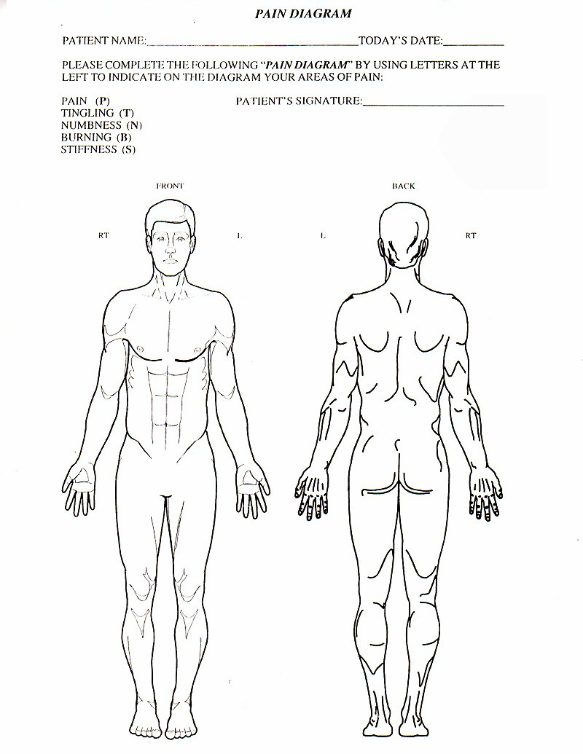
Printed Name______________________ Signature_____________________Date Completed: ____/____/____
I understand that it is unlawful to willfully make a false statement for the purposes of obtaining benefits
Accident Analysis Worksheet
Purpose: Prevent future accident

Employee information
Employee’s Last Name _________________________________ First Name ___________________________ M.I. ________ Social Security # _________________
❑ Male  Female Supervisor Name _________________________________________________ Phone Number ______________________________________
Jobsite/ Address ____________________________________________________________________ Department/Trade ___________________________________
Specific job worked when injured ______________________________________________________ Title _______________________________________________
Years of experience in job ____________________________________________________________ Length of employment ________________________________
Injury Date ___________________________________ Injury time ________  a.m.  p.m. Date reported _______________________________________
Injury outcome:  Fatality  Lost time  Medical  Property damage
Type of injury and body parts injured ________________________________________________________________________________________________________
Accident description
Exact location of accident _________________________________________________________________________________________________________________
Describe job being done (i.e. climbing, ground work, etc.) _______________________________________________________________________________________
What occurred? Describe in sequence: 1) Employee’s location and position 2) How task was being performed 3) What occurred to trigger accident.

Check type of accident:
❑ Struck by  Contacted by  Caught in  Fall – different level  Repetitive motion  Exposure to
❑ Stuck against  Contact with  Caught Between  Fall – Same level  Lifting/overexertion  Slip/trip
❑ Other _______________________________________________________________________________________________________________________________
Analysis of accident causes (check all that apply)
What did the employee do or fail to do that caused or contributed to the accident?
❑ Failure to make secure  Riding hazardous equipment  Used equipment unsafely
❑ Failure to warn or signal  Took unsafe position/posture  Used defective equipment
❑ Protective equipment not worn  Horseplay  Standard procedure deviation
❑ Nullified safety device  Failure to make inoperative  Other _______________________________________________________
What employee condition or characteristic caused or influenced unsafe actions?
❑ Unaware of job hazard  Avoiding discomfort  Influence of illness
❑ Inattentive to hazard  Influence of fatigue  Other personal factors
❑ Trying to avoid extra effort  Impaired vision/hearing  Tried to gain or save time
❑ Low level job _________________________________________________________________________________________________________________________
What condition of tools, equipment or job site caused or contributed to the accident?
❑ Inadequate safety guard/device  Poor housekeeping  Illumination/noise/air contamination
❑ Inadequate warning system  Ergonomic issues  Close clearance/congestion
❑ Fire or explosion hazard  Defective tools/equipment  Hazardous arrangement or storage
❑ Hazardous personal time  Unsecured against movement  Protruding object hazard
❑ Other _______________________________________________________________________________________________________________________________
What causes contributed to above unsafe conditions?
❑ Caused by employee  Defective due to normal use  Management system
❑ Caused by another employee  Poor housekeeping  Outside contractor
❑ Safety inspection failure  Poor preventative maintenance  Unable to determine cause
❑ Faulty design/construction  Defective due to abuse/misuse  Caused by other circumstances __________________________________

Corrective action plan to prevent recurrence
Listed here are a few corrective actions that may help prevent recurrence. Check all that apply. Do not limit yourself to only these tactics. It is a good idea to discuss corrective actions with your safety committee and your loss prevention representative.
❑ Retraining of all employees involved  Improve inspection procedures  Improve illumination/noise conditions
❑ Retraining of other employees  Clean up hazardous conditions  Install/modify safety guards/devices
❑ Corrective interview of employees  Improve cleanup procedures  Improve storage or arrangement
❑ Job reassignment of employee  Require mandatory pre-job training  Improve design or construction
❑ Repair/replace defective equipment  Use safer material and supplies  Check with manufacturer/supplier
❑ Conduct special inspection survey  Improve environmental conditions  Establish purchasing standard
❑ Require personal protective equipment  Perform ergonomic review  Improve training and follow-up training
❑ Improve outside conductor controls  Define safe method  Focus on better on better enforcement
❑ Correction other than these listed _________________________________________________________________________________________________________
Additional comments:

Person responsible for corrective action __________________________________________________________ By what date _______________________________
Investigation by _____________________________________________________________________________ Date _____________________________________
Form reviewed by ___________________________________________________________________________ Date _____________________________________
Confirmation date and corrective action ______________________________________________________________________________________________________

Additional information
Do you have any reason to doubt the validity of this claim?  Yes  No
If yes, please explain.

Has the injured employee had any recent problems with attendance or performance of his or her job?  Yes  No

Are you aware of any other prior injuries or personal conditions the injured employee may have that impacts this claim?  Yes  No
If yes, please explain.

Witness information
Witnesses: Name _______________________________________________________________ Telephone number _____________________________________
Name _______________________________________________________________ Telephone number _____________________________________
Name _______________________________________________________________ Telephone number _____________________________________
Name _______________________________________________________________ Telephone number _____________________________________
Witness comments or pertinent information

RETURN TO WORK / LIGHT DUTY PROGRAM

PURPOSE

To establish guidelines for temporary light-duty work assignments for injured employees.

POLICY

It is the policy of _____(Company Name)_____ to return injured employees, when possible to temporary light-duty work when a work-related injury or illness prevents those individuals from returning to their regular job.

While working under this program, injured employees will retain the rate of pay in effect at the time of injury or illness. A temporary light-duty assignment will not change a worker’s benefits coverage and premium amounts. Any injured employee who is determined to be disabled will be treated according to the provisions of the American with Disabilities Act (ADA). _____(Company Name)_____ reserves the sole right to determine the availability, type, and duration of all temporary light-duty assignments on a case by case basis.

DEFINITIONS

- Injured Employee -- An employee that has suffered a job related injury or illness which results in a compensable claim.

- Workers Compensation Representative (WCR) – The designated representative that is responsible for the management of the workers compensation program in an operating unit.

- Light-duty Work – Temporary jobs which the injured employee can perform while recovering from the illness or injury. These job assignments are normally limited to ninety (90) calendar days.

PROCEDURE

- Injured Employee

- Reports to WCR when released to temporary light-duty work by treating physician within one working day for assignment to the job.

- Meets with supervising manager of temporary light-duty job and WCR to review policy and job description.

- Reports any change in condition to WCR and arranges to see the physician if unable to work due to increase symptoms (treating physicians must authorize additional time loss.)

- Maintains weekly contact with WCR

- If an injured employee refuses medically approved light-duty assignment(s), ____(Company Name)____ will consider the refusal a voluntary resignation. Workers Compensation, Disability, or other benefits may be subject to termination upon this refusal of work.

- While working in temporary light-duty position, an injured employee is responsible to the supervising manager of the assigned department. The employee is expected to follow the same performance and safety standards as a regular employee in the department. This includes satisfactory completion of work assignments, reporting to work on time, completing scheduled shifts, arranging for time away from work with the supervising manager.

- Submits time cards signed by supervising manager weekly to WCR.

- Employees must adhere to the written work restrictions outlined by the treating physician.

- Workers Compensation Representative (WCR)

- Obtain physician’s and injured employee’s signature on authorized forms.

- Meets with injured employee and supervisor of temporary light-duty work. Reviews policy, explains work / supervisor responsibilities, including physical restrictions, reporting mechanism, time cards and rate of pay.

- Notifies workers compensation provider of injured employee’s return to temporary light duty scheduled hours and rate of pay.

- Make an appropriate referral if at any time it appears that the injured employee will be unable to return to work within ninety (90) days of the start date.

- Supervising Manager of Temporary Light-duty Department/Job

- Meets with injured employee and WCR to review status of injured employee and parameter of physician’s light-duty activity prescription.

- Orients injured employee to department and temporary light-duty job. Communicated clear understanding of expectations.

- Monitors employee’s performance which includes working within expected parameters of light-duty activity prescription, attendance quality and quantity of work assigned.

- Sign time cards and verifies hours weekly.

- Notifies WCR of any problems that arise, such as employee’s inability to perform assigned tasks, absenteeism, or other performance problems.

- Takes corrective action, initiates disciplinary measures as necessary, using Human Resources Department as a resource.

- Completes progress report of work and sends to WCR monthly, or as needed.

RETURN TO WORK / LIGHT DUTY PROGRAM AGREEMENT
____(Company Name)____ actively participates in a Return to Work / Light Duty Program which is adhered to and administered at the employer’s discretion. In the event that you are working in a light duty assignment, you are responsible to know your restrictions and must be cognizant of them at all times.

Do not attempt tasks that exceed the restrictions given to you by the treating physician. If a question exists about the task(s) at hand and your restrictions, advice your supervisor immediately. Do not attempt tasks which are not within your restrictions.

The medical restrictions are in effect twenty-four (24) hours per day. Exercise caution at all times to see that the restrictions are maintained. If you have questions regarding your restrictions, consult with the treating physician.

An employee who conducts activities which are inconsistent with the medical restrictions and/or treatment matters is subject to disciplinary action from the employer and possible loss of compensation from the Worker Compensation provider.

If an injured employee refuses medically approved light-duty assignment(s), ____(Company Name)____ will consider the refusal a voluntary resignation. Workers Compensation, Disability, or other benefits may be subject to termination upon this refusal of work.

By signing, I hereby fully understand and accept ___(Company Name)___ Return to Work / Light Duty Program.

Employee’s Signature Date

_____________________
Employee’s Printed Name

Light Duty Available

Duty Activity Involved

Injured Employee – Please give this to your doctor on your first visit to complete.

PHYSICAL CAPABILITIES EVALUATION

Employee Name and Job Title____________________________________________________________________________

1. How often during the work day can the patient; Lift/Carry, Push/Pull:

 | Never | Occasionally  (0-33%) 1-3 Hr | Frequently  (34-66%) 4-6 Hr | Constantly  (67-100%) 6-8 Hr
1-10 lbs
11-20 lbs
21-50 lbs
51-100 lbs
Over 100lbs

2. Can the patient perform the following tasks?

Climbing □
Balancing □
Stooping □
Kneeling □
Grasping □
Crouching □
Crawling □
Reaching □
Handing □
Feeling □
Bending □
Overhead Lifting □
Working on Ladders □
Fine Manipulation □

3. Is the patient capable of repetitive use of the hands?
Right hand □ Yes □ No Left hand Yes □ No

4. Can the patient be exposed to?
□ temperature extremes □ excessive noise □ inhalants □ chemicals

5. Please check the degree of work you feel this patient is capable of performing. Vol II/Dictionary of Occupational Titles, pages 654-655 published by the US Dept of Labor classifies 5 degrees of work in terms of strength required:

_____Sedentary Work: Lifting 10 lbs maximum and occasionally lifting/carrying such articles dockets, ledgers and small tools. Involves a certain amount of time sitting, a certain amount of walking and standing is often necessary in carrying out job duties. Jobs are sedentary if walking or standing are required only occasionally.

_____Light Work: Lifting 20 lbs. maximum with frequent lifting/carrying of objects weighing up to 10 lbs. Even though the weight lifted may be only a negligible amount, a job is in the category when it involves sitting most of t he time with a degree of pushing and pulling arm/leg controls, or when it requires walking or standing to a significant degree.

_____Medium Work: Lifting 50 lbs maximum with frequent lifting/carrying of objects weighing up to 25 lbs.

_____Heavy Work: Lifting 100 lbs. maximum with frequent lifting/carrying of objects weighing up to 50 lbs.

_____Very Heavy Work: Lifting objects in excess of 100 lbs. with frequent lifting/carrying of objects weighing 50 lbs. or more.

6. Date patient can return to work at his/her regular occupation: ___________________

Date patient can return to work in transitional duty capacity:_____________________

Signed:_____________________ Title:____________________Date:___________________

Please fax completed form to Attn: Human Resources Mgr. Fax: Thank you.

